HOW TO CREATE GITHUB ACCOUNT

1. Open google chrome and search github.com the search bar
2. Enter your Email-ID required and click sign up

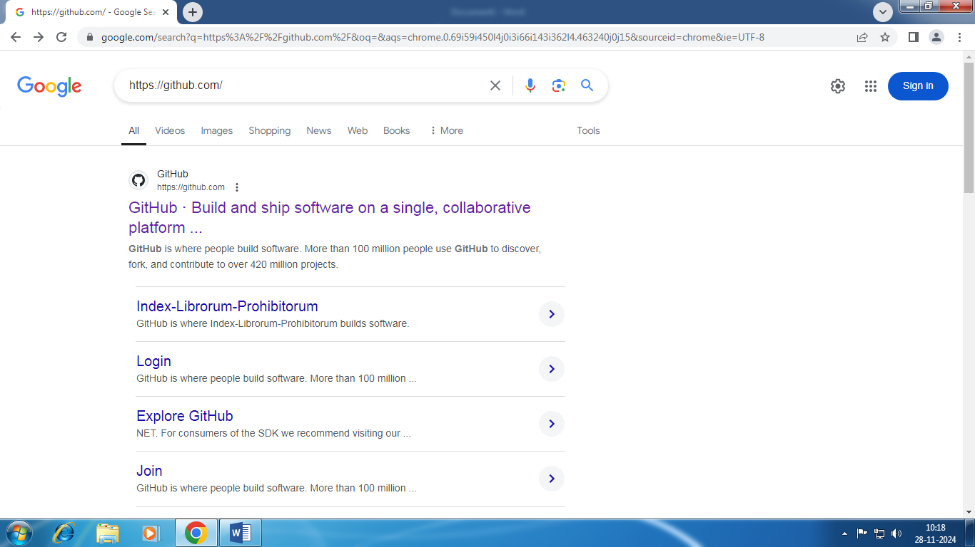

1. Enter your email and click sign up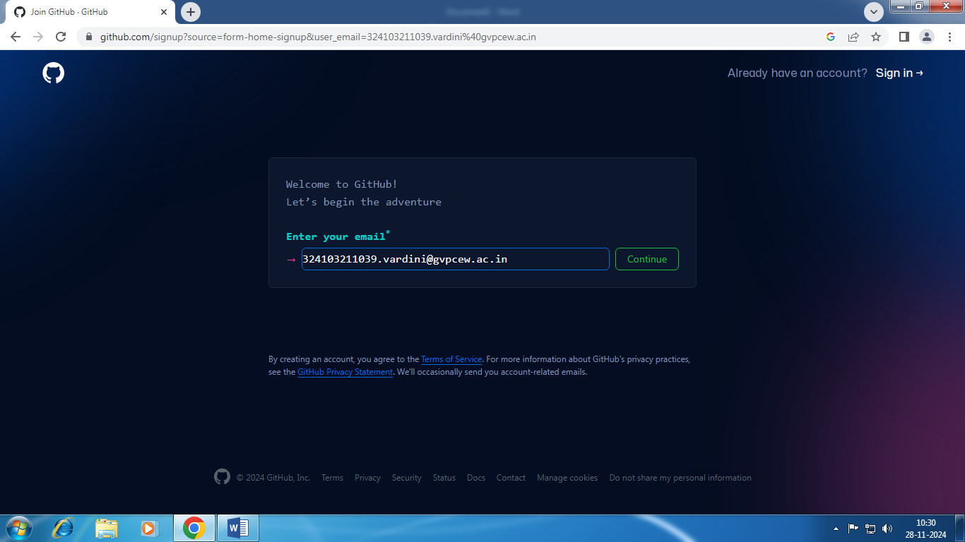
2. Click continue
3. Enter password and user name
4. Click sign up
5. Git hub account is created

